Healthcare Claims Analysis

Executive Dashboard & Business Intelligence Case Study
Amanda Benavidez
Tools
SQL • Google BigQuery • Looker Studio
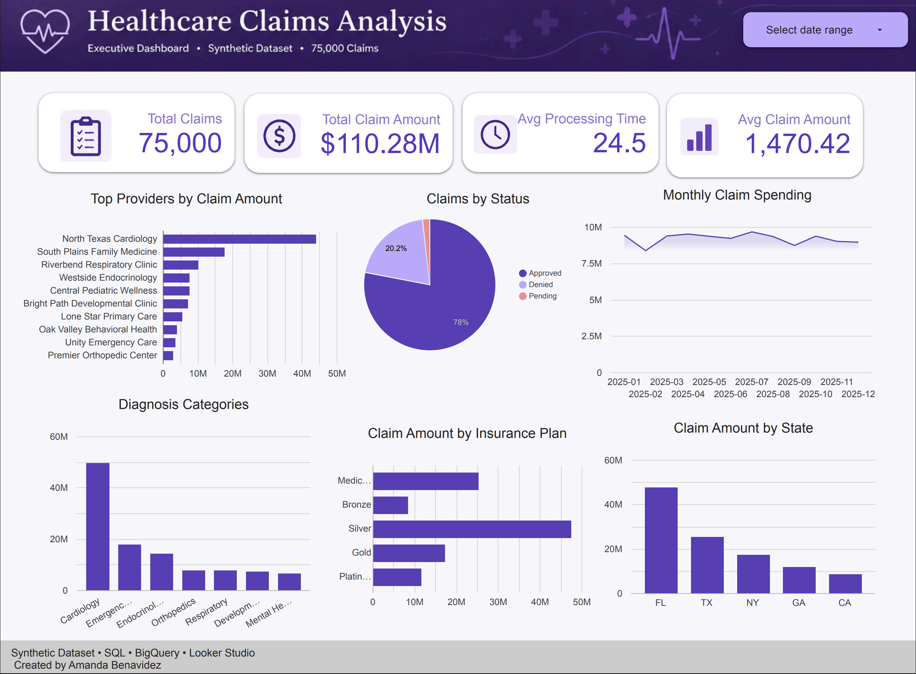
Figure 1. Executive dashboard developed in Looker Studio using data stored in Google BigQuery. The dashboard provides healthcare administrators with an overview of claim volume, spending trends, provider performance, diagnosis costs, insurance plan utilization, and geographic distribution.
Data Analytics Portfolio Project · July 2026

Business Questions Answered
- Which providers generated the highest claim amounts?
- Which diagnosis categories had the highest costs?
- What percentage of claims were approved?
- Which insurance plans generated the most spending?
- Which states had the highest claim amounts?
- What was the average claim processing time?

This project demonstrates my ability to design a relational database, write SQL queries to answer business questions, analyze large datasets using Google BigQuery, and communicate findings through an executive dashboard in Looker Studio. Throughout the project, I focused on translating raw healthcare claims data into actionable insights that support informed business decisions.

Healthcare Claims Analysis

SQL • Google BigQuery • Looker Studio
Author: Amanda Benavidez
Project Type: Healthcare Data Analytics Dashboard

Executive Summary
Healthcare organizations process thousands of insurance claims every month, making it difficult to quickly identify spending trends, approval rates, provider performance, and diagnosis patterns. This project demonstrates how SQL, Google BigQuery, and Looker Studio can be combined to transform raw healthcare claims data into an executive dashboard that supports faster, data-driven decision-making.
Using a synthetic dataset of 75,000 healthcare claims, I designed a relational database, analyzed claims data with SQL, and created an interactive executive dashboard that summarizes key performance metrics, claim spending, provider activity, insurance plan distribution, and geographic trends.

Business Problem
Healthcare administrators need quick access to reliable metrics that help answer questions such as:
- How much has been spent on insurance claims?
- Which providers generate the highest claim amounts?
- What percentage of claims are approved versus denied?
- Which diagnosis categories account for the highest costs?
- Which insurance plans receive the largest claim amounts?
- Which states generate the most claim spending?
Without a centralized dashboard, answering these questions requires manually reviewing thousands of records.

Project Goals
The goal of this project was to:
- Design a relational healthcare claims database
- Write SQL queries to answer business questions
- Analyze healthcare spending trends
- Create an executive dashboard for decision-makers
- Present findings in a clear, visually appealing format

Dataset
This project uses a synthetic dataset containing 75,000 healthcare insurance claims created for educational and portfolio purposes.
The database includes:
- Patients
- Providers
- Insurance Plans
- Diagnoses
- Claims
Key fields include:
- Claim Amount
- Processing Time
- Diagnosis Category
- Insurance Plan
- Provider
- Patient State
- Claim Status
- Service Date
Tools Used

Tool | Purpose
SQL | Data querying and analysis
Google BigQuery | Cloud data warehouse
Looker Studio | Dashboard creation
GitHub | Project documentation
Google Cloud | Database hosting

Dashboard Overview
The executive dashboard includes:
- Total Claims
- Total Claim Amount
- Average Processing Time
- Average Claim Amount
- Top Providers by Claim Amount
- Claims by Status
- Monthly Claim Spending
- Claim Amount by Diagnosis Category
- Claim Amount by Insurance Plan
- Claim Amount by State

Key Insights

Total Claims Processed
75,000 claims were analyzed.

Total Claim Spending
Healthcare claims totaled approximately $110.28 million.

Average Claim Amount
The average insurance claim was approximately $1,470.

Average Processing Time
Claims required an average of 24.5 days to process.

Provider Performance
North Texas Cardiology generated the highest total claim amount among all providers, followed by South Plains Family Medicine and Riverbend Respiratory Clinic.

Claim Status
The majority of claims were approved, with a smaller percentage denied or pending. This suggests an efficient claims approval process while still highlighting opportunities to investigate denied claims.

Diagnosis Trends
Cardiology accounted for the highest claim spending, indicating cardiovascular-related care represented the largest share of overall healthcare costs in this dataset.

Insurance Plan Analysis
Silver plans generated the highest total claim amount, followed by Medicare Advantage and Gold plans.

Geographic Trends
Florida produced the highest claim amount, followed by Texas and New York.

Recommendations
Based on this analysis, healthcare administrators could consider:
- Investigating why cardiology accounts for the largest share of spending.
- Reviewing high-volume providers to identify operational efficiencies.
- Monitoring denied claims to reduce unnecessary rework.
- Evaluating insurance plan utilization to improve cost management.
- Using monthly spending trends to forecast future claim expenses.

What I Learned
This project strengthened my ability to work with SQL in a real-world scenario by designing relational tables, writing analytical queries, and joining multiple datasets. I also gained experience using Google BigQuery to manage cloud-based data and Looker Studio to create an executive dashboard that communicates insights clearly.
Beyond the technical skills, I learned the importance of presenting data in a way that is easy for decision-makers to understand. Building the dashboard reinforced how thoughtful design and storytelling can make complex data more accessible and actionable.

Skills Demonstrated
- SQL
- Google BigQuery
- Relational Database Design
- Data Cleaning
- Data Analysis
- Dashboard Design
- Data Visualization
- Business Intelligence
- Analytical Thinking
- Data Storytelling

